Likelihood 2019, Homework #4

You may work with others but the work you turn in must be your own.

The task here is to model the recombination process that generates a gamete from two parental chromosomes as a Markov Chain. Consider the gamete that ultimately contributes to a zygote as a random product of meiosis. The chain relevant to Bailey’s maternal grandfather is pictured below:

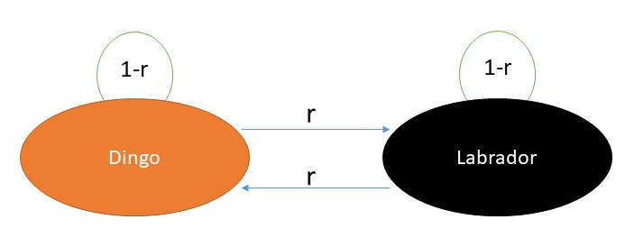

With equal probability, the chromosome (Markov chain) starts with maternal chromosome (Dingo is discrete state 1) or the paternal chromosome (Labrador is discrete state 2). The gamete is formed by copying the chromosome, base pair by base pair. If there is no recombination event then the chain stays in same state (probability 1-r per bp). If a recombination event occurs, then the chain switches into the alternative state (probability = r per bp). If we walk along a chromosome from start to finish, and color code the chain by state at each step, the gamete might look like this:

Base position
0 ---------------------------------------------------→ 22,003,489

In this example, recombination events occurred three times. The first was around bp 6,500,000, the second around 8,100,000, and the last around 19,000,000.

The data for this problem are these reported positions for the first 20 chromosomes (file = “Mutt.gamete.data.xlxs”).

1. Write the likelihood equation treating each chromosome as an independent chain.
2. Solve for the maximum likelihood of the only parameter in the model (r).
3. Using the data, determine the MLE for r (per bp) for Bailey’s grandfather and the log-likelihood of the data with r=to this MLE. We will use this log-likelihood to contrast with a Non-Markovian model of recombination.

Not required for this homework, but entirely fascinating, here is Bailey’s actual chromosomal parentage as a function of 8 color coded ancestors:
