Likelihood 2019, Homework 2

Leopard frogs have several different color polymorphisms. Some populations have two types, the standard spotted morph and the solid ‘burnsi’ morph. This coloration differences is due to a single genetic locus with the standard allele dominant to the burnsi allele. Let q = the frequency of the burnsi allele and assume that this locus is in Hardy-Weinberg equilibrium within the population. You take a random sample from a natural population. The data: n_{S} spotted frogs and n_{B} burnsi frogs.

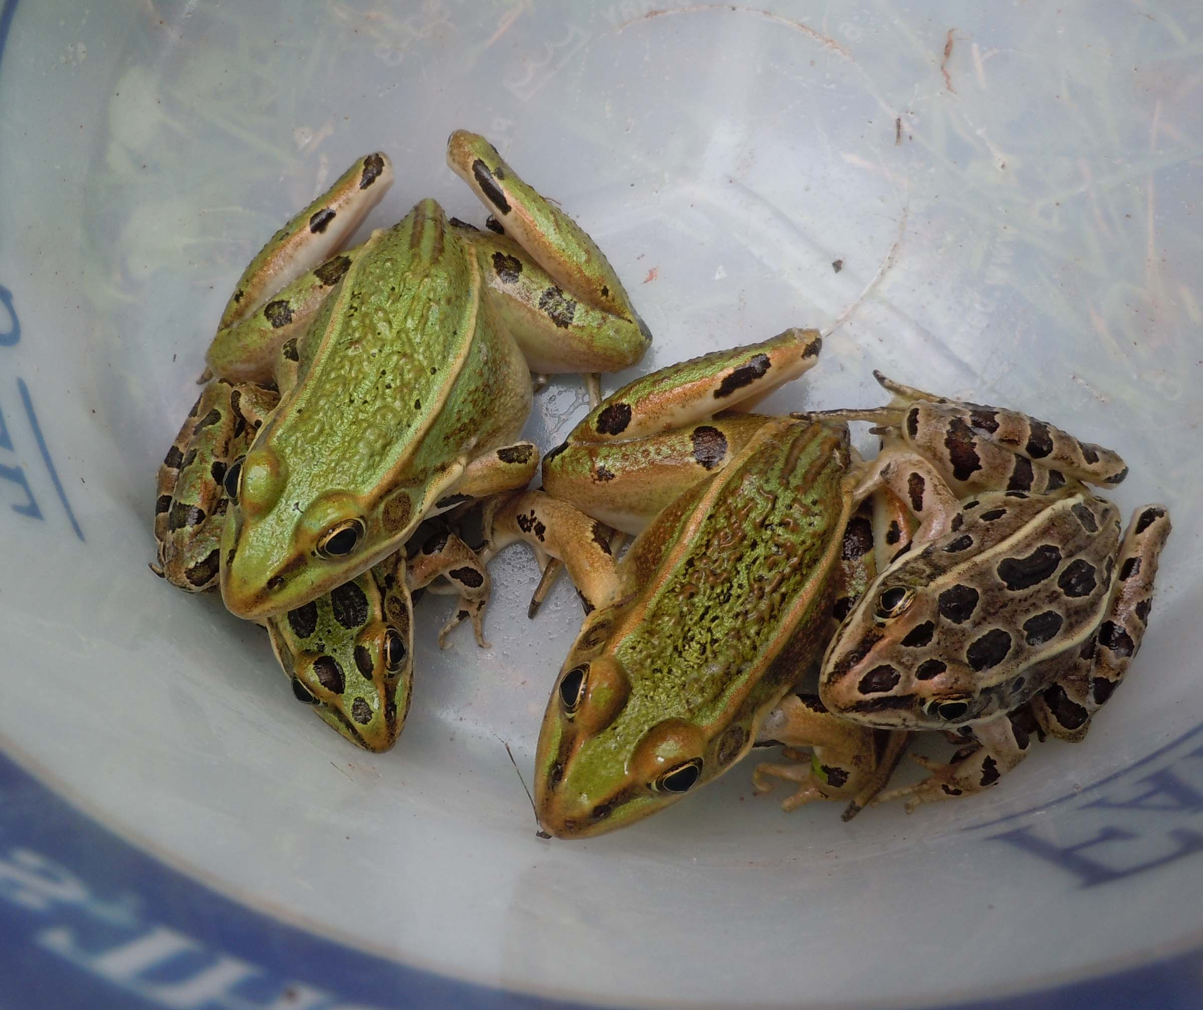
1. Determine the log-likelihood function for the data and solve for the MLE of q.

2. Given n_{S} = 80 and n_{B} = 32, plot the log-likelihood function, determine the MLE, and determine a lower and upper-bound using the 1.92 log-likelihood drop method.

burnsi and brown morph Leopard frogs. Photo by Loba Wolf

3. You go to a separate population and collect 126 frogs (n_{S} = 101 and n_{B} = 25). What is the MLE for q if you assume that both samples are from one panmictic population? What is the log-likelihood of the data under this assumption (the null hypothesis)?

4. Perform a likelihood ratio test of the null hypothesis. Is allele frequency different between the two populations?

